**Midterm Project**

The video rental shop classifies movie titles according to their type: comedy, western, classical, science fiction, cartoon, action, musical, or new release. Each type contains many possible titles, and most titles within a type are available in multiple copies. For example, note the summary in the following table of the relationship between video rental type and title.

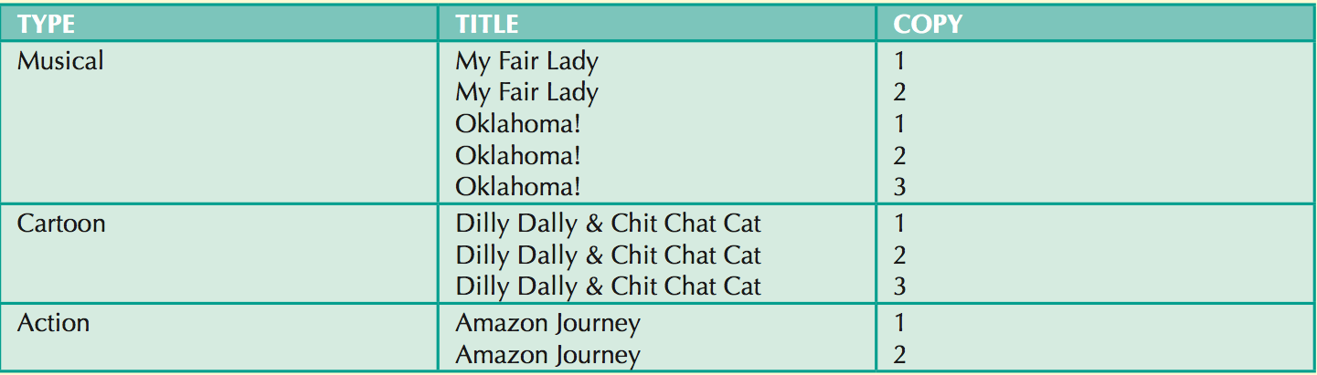

Keep the following eight conditions in mind as you design the video rental database:

* The movie type classification is standard; not all types are necessarily in stock.
* The movie list is updated as necessary; however, a movie on that list might not be ordered if the video shop owner decides that the movie is not desirable for some reason.
* The video rental shop does not necessarily order movies from all vendors on the vendor list; some vendors on the vendor list are merely potential vendors from whom movies may be ordered in the future.
* Movies classified as new releases are reclassified to an appropriate type after they have been in stock for more than 30 days. The video shop manager wants to have an end-of-period (week, month, year) report for the number of rentals by type.
* If a customer requests a title, the clerk must be able to find it quickly. When a customer selects one or more titles, an invoice is written. Each invoice can contain charges for one or more titles. All customers pay in cash.
* When a customer checks out a title, a record is kept of the check-out date and time and the expected return date and time. When rented titles are returned, the clerk must be able to check quickly whether the return is late and to assess the appropriate late return fee.
* The video store owner wants to generate periodic revenue reports by title and by type. The owner also wants to generate periodic inventory reports and track titles on order.
* The video store owner, who employs two (salaried) full-time and three (hourly) part-time employees, wants to keep track of all employee work time and payroll data. Part-time employees must arrange entries in a work schedule, while all employees sign in and out on a work log.

Design a video rental database. You need an ER diagram (conceptual presentation) and a logical presentation (table structure with a few fabricated records).

Each group needs to prepare a 10-min presentation on:

* Overview of the database
* Entities and relationships
* How you addressed the eight conditions (one by one)
* Some highlights of your design
* Challenges you have had